**Agile model/ agile methodology/ agile process:**

Agile is an iterative and incremental process.

**Agile principles**

* Customer no need to wait for long time
* We develop, test release piece of s/w to customer with few no. of features
* We can accept/ accomodate requirement changes

There will be good communication b/w customer, business analyst, developer and tester.

**Advantages:**

* Requirement changes are allowed in any stage of the development (or) we can accommodate requirement changes in the middle of the development.
* Release will be very fast.(quick)
* Customer no need to wait for long time.
* Good communication b/w team.
* It is very easy to adopt model.

**Disadvantage:**

* Less focus on design and documentation since we deliver s/w very faster

**Scrum:**

Scrum is a framework through which we build s/w product by following agile principles.

Scrum includes group of people called as scrum team.

* Product owner
* Scrum master
* Dev team
* QA team

**Product owner:**

* Defines features of the product
* Prioritize features according to market value
* Adjust features and priority every iteration as needed.
* Accept and reject work results.

**Scrum master:**

* The main role is facilitating and driving the agile process.

**Developer and QA:**

* Develop and test s/w

**Scrum terminology:**

**User story:** a feature or module in a s/w

**Epic:** collection of user stories

**Product backlog:** it is like excel document contains list of all user stories, prepared by product owner.

**Sprint/iteration:** a period of time to complete the user stories, decided by product owner and team, usually 2-4 weeks of time.

**Sprint planning meeting:** meeting conducts with the team to define what can be delivered in the sprint and duration.

**Sprint backlog:** list of committed stories by Dev/QA for specific sprint.

**Scrum meeting:** meeting conducted by scrum master everyday 15min called as scrum call/ Stand up call

What did you do yesterday?

What will you do today?

Are there any impediments/blocker in your way?

**Sprint retrospective meeting:**

Conduct meeting after completion of sprint. The entire team, both scrum master and

Product owner for discussing about what went wrong and what went well and what

Are the other thing to be implemented for upcoming sprints.

**Story point:** Rough estimation of user stories, will be given by Dev and QA team in form of Fibonacci series.

**0 1 1 2 3 5 8 .** **. . . .**

1 story point = 1 hour/ 1 day

Login -🡪 Dev 5 QA 🡪 3 = 8 hour/1 day.

**Burndown chart:**  shows how much work remaining in the sprint. Maintained by the scrum master daily.

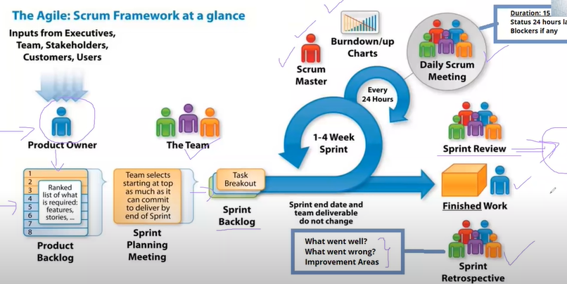

**What are roles , artefacts and ceremonies in agile process?**

**Roles:**

* Product owner
* Scrum master
* Team

**Artefacts:**

* product backlog
* sprint backlog
* burndown chart

**Ceremonies:**

* sprint planning
* daily scrum
* sprint review and sprint retrospective

